FINAL EXAMINATION . TIME ALLOWED: 90’
Subject: Linear Algebra. No books allowed.

1/ Find the matrix , such that 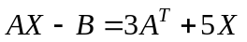, where 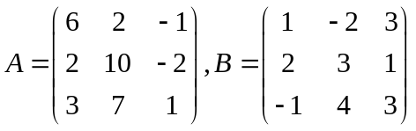.

2/ Compute the determinant of the matrix 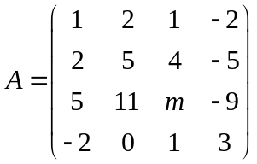.

3/ In 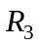 with the inner product ,
given the subspace 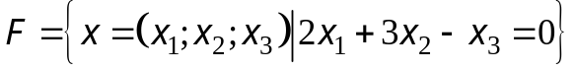.
Find one basis and a dimension of the orthogonal complement 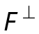 of the subspace F.

4/ Let 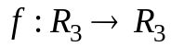 be the linear transformation and 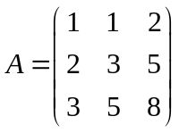 be the matrix of the
transformation in the basis 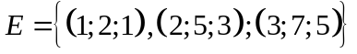.
a/ Compute 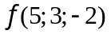.
b/ Find one basis and a dimension of the kernel of the mapping 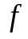.

5/ Let 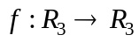 be the linear mapping and .
a/ 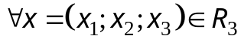, find 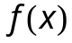
b/ Find the matrix  of the linear transformation f in the basis 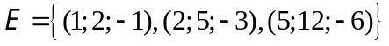.

6/ Diagonalize the matrix 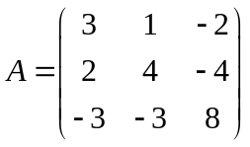, if possible.

7/ Describe the geometrical relationship of the three planes represented by the following system of
equations 

  

